**DAILY REPORT (as an individual)**

|  |  |
| --- | --- |
| **Project Name:** | Loanalytic-Web |
| **Day:** | June 25, 2019 |
| **Name:** | Gouthami Pasham |

**REPORT:**

|  |  |
| --- | --- |
| **Your planned objectives** | * Working on validating the user login validation. * Creating the loan calculator front end. |
| **Your achieved objectives** | * Created the loan calculator front end. * Validated the entry in the User login page. |
| **Your missed objectives and make-up plan** | * Authenticating the user with database credentials. |
| **Your plan for the next day** | * Working on user Authentication. |

**Worked on Validation of the user. The user name can be only alphabets no numbers allowed and the password can be a combination of numbers and alphabets.**

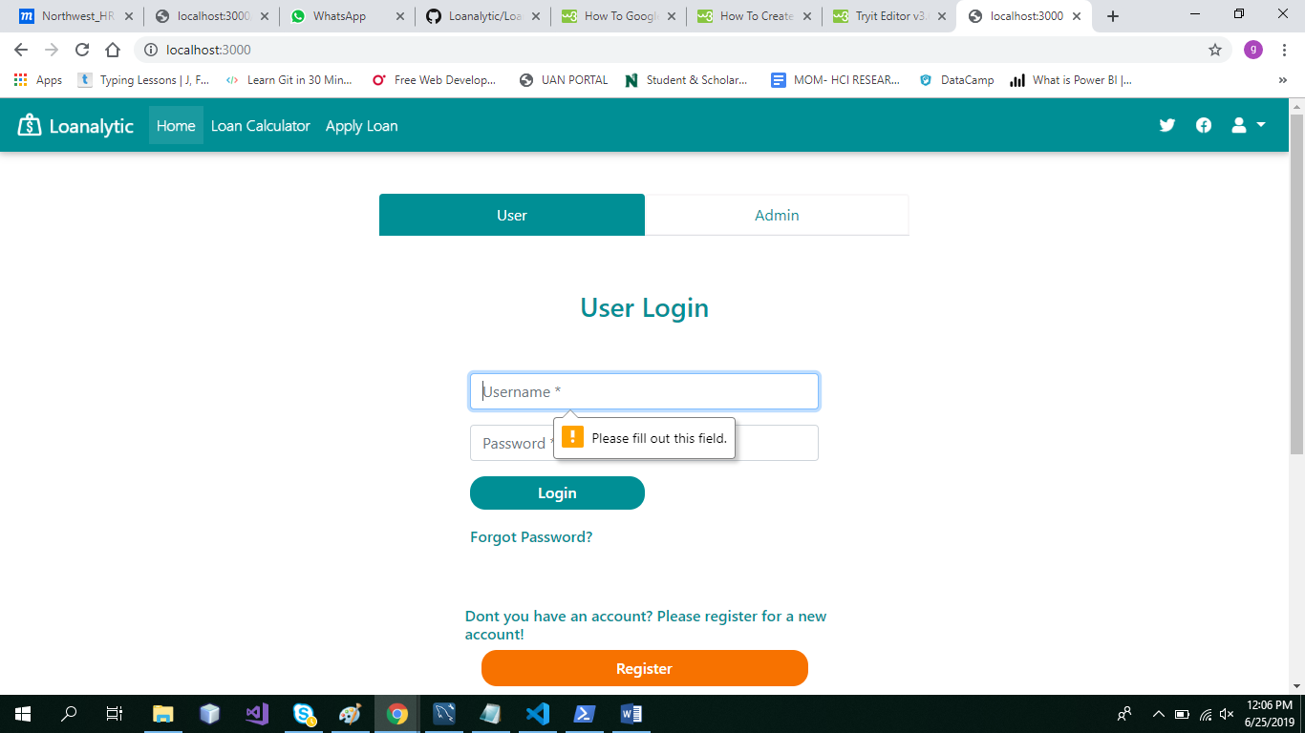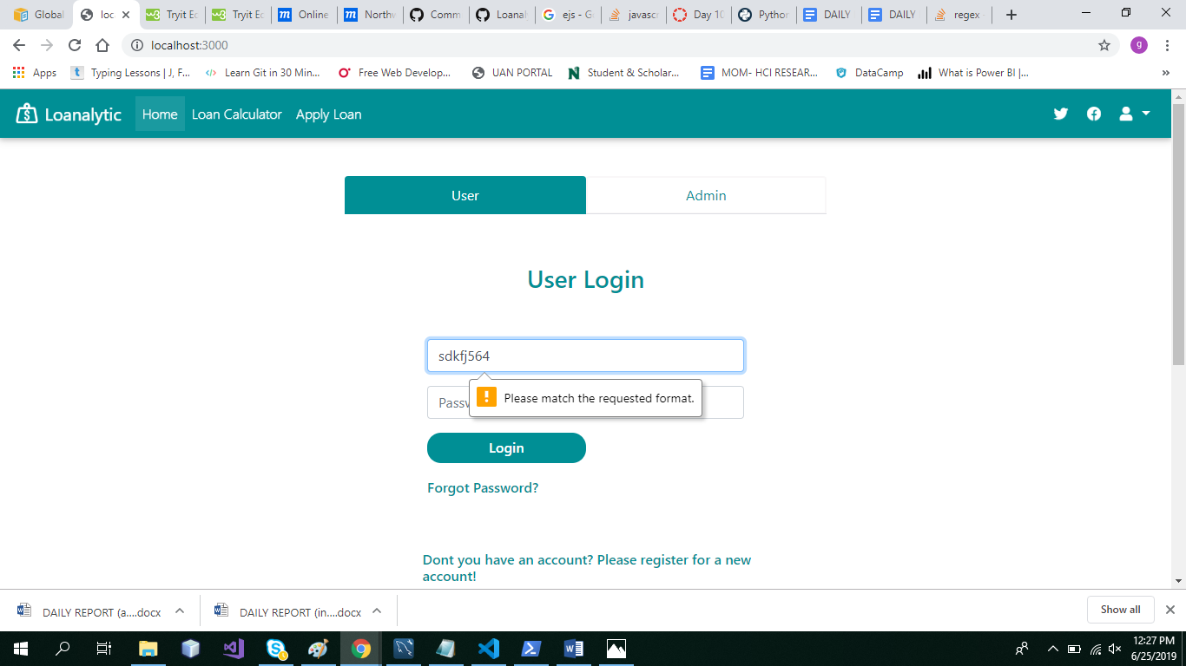

If all the credentials are supplied as required in the pattern the page would be navigated to the home page. Here is the code modifications made for validations.

